Name-Mr. Jain Samkitkumar Hasmukhlal
Roll No.-20 BEIT
Title- Write a case study on Digital Library.

Digital Library

Need:

- The Internet and World Wide Web provide the impetus and technological environment for the development and operation of a digital library. The Internet provides the TCP/IP and or its associated protocol for accessing the information and web provide tools and technique for publishing the information over Internet.

- In the digital environment it is reasonable to say that a central back up or archive should be created at the national level, which will store information out put of the region as well as information from out side the country. Some of the requirement for a digital libraries are:

- Audio visual: Color T.V., V.C.R., D.V.D., Sound box, Telephone etc.
- Computer: Server, P.C. with multimedia, U.PS. Etc
- Network: LAN, MAN, WAN, Internet etc.
- Printer: Laser printer, Dot matrix, Barcode printer, Digital graphic printer etc
- Scanner: H.P. Scan jet, flatbed, Sheet feeder, Drum scanner, Slide scanner, Microfilming scanner, Digital camera, Barcode scanner etc
- Storage devices: Optical storage device, CD-ROM, Jukebox etc.
- Software: Any suitable software, which is interconnected and suitable for LAN and WAN connection.PC

Introduction

Information and Communication Technology has revolutionized the concept of libraries. Each and every library is slowly getting digitized. A 'digital library' comprises digital collections, services and infrastructure to support lifelong learning, research, scholarly communication as well as preservation and conservation of our recorded knowledge. It is also a process of democratization of information. This article will discuss the factors that will necessitate the traditional libraries to get digitized, as well as the definition, advantages and disadvantages of digital libraries, the requirement for building a digital library etc.

We are in the age of a networked society where information technology in addition to its use in all spheres of human activity has been used extensively to record, store, and disseminate the information in the digital form. Information technology has almost converted the world into a global village. The revolution in the information technology sector is influencing medical information and information . Libraries are also changing to meet the demand put on them. The new generation whose demand for information is never met is always demanding that traditional libraries should be developed as a well equipped and interconnected as digital libraries.

History

The digital library concept can be traced back to the famous papers of foreseer scientists like Vannevar Bush and J.C.R. Licklider identifying and pursuing the goal of innovative technologies and approaches toward knowledge sharing as fundamental instruments for progress. Bush (Bush, 1945) devised “a device in which an individual stores all his books, records, and communications, and which is mechanized so that it may be consulted with exceeding speed and flexibility.”.

Moreover, on top of it there is “a transparent platen. On this are placed longhand notes, photographs, memoranda, all sorts of things”. Because of the lack of digital support, he identified in “improved microfilm” the means for content storage and exchange: “contents are purchased on microfilm ready for insertion. Books of all sorts, pictures, current periodicals, newspapers, are thus obtained and dropped into place”. Of course, he envisaged also support for knowledge discovery (“provision for consultation of the record by the usual scheme of indexing”), access (“to consult a certain book, he taps its code on the keyboard, and the title page of the book promptly appears before him”) and management (“new forms of encyclopedias will appear, ready made with a mesh of associative trails running through them, ready to be dropped into the memex and there amplified”).

Licklider realized that computers were getting to be powerful enough to support the type of automated library systems that Bush had described and in 1965, wrote his book (Licklider, 1965) about how a computer could provide an automated library with simultaneous remote use by many different people through access to a common database. Because of this, Licklider is also considered a pioneer of Internet and in its book he established the connection between Internet and digital library. Thus, it is not surprising that research and development activity on digital libraries started in the early 1990s, with the Internet proliferation, and that Internet has created unprecedented possibilities to discover and deliver human knowledge.

What is digital library?

According to Arms a digital library is a managed collection of information with associated services where the information is stored in digital format and accessible over a network.

A digital library is an organized collection of digitized material or it’s holding in the digital form, which can be accessible by a computer on the network by using TCP/IP or other protocol.

Digital library: It is a later stage of electronic library. In digital library high speed optical fiber are used for LAN and the access is over WAN and provide a wide range of Internet based services i.e. audio and video conferencing and like other. The majority of the holding of a digital library is in the computer readable form and also acts as a point of access to other on line sources.

Architecture

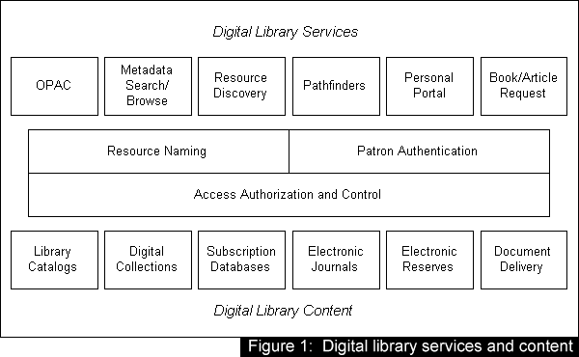

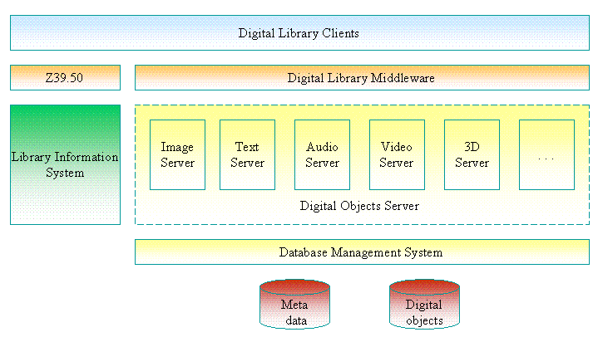
Figure 2:Administration and Maintainance

Advantages of the Digital Library

A digital library is not confined to a particular location or so called building it is virtually distributed all over the world. The user can get his/ her information on his own computer screen by using the Internet. Actually it is a network of multimedia system, which provides fingertip access.

- No physical boundary: The user of a digital library need not to go to the library physically, people from all over the world could gain access to the same information, as long as an Internet connection is available.
- Round the clock availability: Digital libraries can be accessed at any time, 24 hours a day and 365 days of the year
- Multiple accesses: The same resources can be used at the same time by a number of users.
- Structured approach: Digital library provides access to much richer content in a more structured manner i.e. we can easily move from the catalog to the particular book then to a particular chapter and so on.
- Information retrieval: The user is able to use any search term bellowing to the word or phrase of the entire collection. Digital library will provide very user friendly interfaces, giving click able access to its resources.
- Preservation and conservation: An exact copy of the original can be made any number of times without any degradation in quality.
- Space: Whereas traditional libraries are limited by storage space, digital libraries have the potential to store much more information, simply because digital information requires very little physical space to contain them. When the library had no space for extension digitization is the only solution.
- Networking: A particular digital library can provide the link to any other resources of other digital library very easily thus a seamlessly integrated resource sharing can be achieved.
- Cost - The cost of maintaining a digital library is much lower than that of a traditional library. A traditional library must spend large sums of money paying for staff, book maintains, rent, and additional books. Digital libraries do away with these fees.

Disadvantages of the Digital Library

The computer viruses, lack of standardization for digitized information, quick degrading properties of digitized material, different display standard of digital product and its associated problem, health hazard nature of the radiation from monitor etc. makes digital libraries at times handicap.

- Copyright: - Digitization violates the copy right law as the thought content of one author can be freely transfer by other without his acknowledgement. So One difficulty to overcome for digital libraries is the way to distribute information. How does a digital library distribute information at will while protecting the copyright of the author?
- Speed of access: - As more and more computer are connected to the Internet its speed of access reasonably decreasing. If new technology will not evolve to solve the problem then in near future Internet will be full of error messages.
- Initial cost is high: - The infrastructure cost of digital library i.e. the cost of hardware, software; leasing communication circuit is generally very high.
- Band width: - Digital library will need high band for transfer of multimedia resources but the band width is decreasing day by day due to its over utilization.
- Efficiency: - With the much larger volume of digital information, finding the right material for a specific task becomes increasingly difficult.
- Environment: - Digital libraries cannot reproduce the environment of a traditional library. Many people also find reading printed material to be easier than reading material on a computer screen.
- Preservation: - Due to technological developments, a digital library can rapidly become out-of-date and its data may become inaccessible.

Examples of Digital Libraries

Image libraries

- NASA Multimedia: Link (searchable database of over 300,000 NASA images)
- Smithsonian Images (database): Link
- University of Texas' Perry-Castañeda Library Map Collection
- Louisiana Digital Library
- Indiana Historical Society Digital Image Library
- ARTstor Digital Library (for education and scholarship)
- New York Public Library Digital Gallery
- University of Miami Libraries, Cuban Heritage Collection
- The Complete Writings and Pictures of Dante Gabriel Rossetti - A Hypermedia Archive
- Shodhganga

Video and multimedia libraries

- Digital Video Library:
- JFK Jr. Forum Video and Podcast Archive

Map libraries

- Alexandria Digital Library
- Library of Congress Historical Map Collections
- TerraServer CUSA

CONCLUSION:
Thus we made a detailed study of working, architecture, advantages, disadvantages of Digital Library. We also seen different types of digital libraries available in market.

